LEBANON AREA BASEBALL ACADEMY PLAYER/GUARDIAN CONTRACT
THANKS FOR CHOOSING TO PARTICIPATE IN A LEBANON AREA BASEBALL ACADEMY EVENT! INCLUDES ALL EXPLOSIVE VELOCITY PROGRAMS. IT IS THE PARTICIPANTS, PARENT OR GUARDIANS RESPONSIBILITY TO ENSURE THE PARTICIPANT IS HEALTHY ENOUGH TO PARTICIPATE IN ALL WORKOUTS WHERE THERE WILL BE PHYSICAL ACTIVITIES.

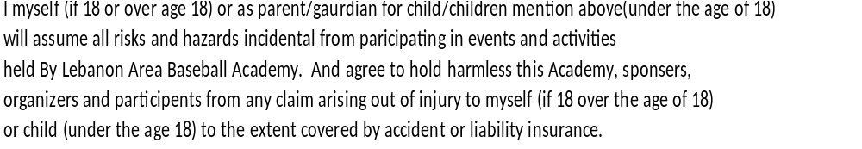

THIS STATE’S I HAVE READ AND UNDERSTAND THE CONTRACT AND CONSEQUENCES OF NOT ABIDING BY THAT STATED WITH IN THIS CONTRACT. WE HOPE YOUR KID HAS A WONDERFUL EXPERIENCE AND IS ABLE TO IMPROVE THROUGH THEIR PARTICIPATION IN OUR EVENTS AS A BALL PLAYER AND AS A PERSON.

PARENT/GUARDIAN: (PRINT NAME)
(SIGNATURE) DATE:
PLAYER: (PRINT NAME)

