2017 Lebanon Area Baseball Academy Rules For Competitive Leagues And Tournaments
ALL TEAMS WILL BE REQUIRED TO PROVIDE 2 GOOD CONDITION APPROVED BASEBALLS/GAME
Tournaments
Governing Rules
USSSA by-laws and MLB National League rules will be used with USSSA taking president when applicable.
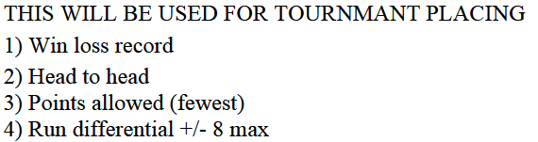
Time Limits and Innings Played
Time limits may be shortened if weather conditions warrant. There will not be extra innings in pool play. An inning starts when the 3rd out is made with the home team batting and if there is any time left at all at that point the next inning will be played if there are innings left and scored don’t require stoppage. Most round robin formats will play 1 extra inning using the California tie breaker (SOME ROUND ROBIN FORMATS MAY NOT HAVE EXTRA INNINGS IF SO IT WILL BE POSTED ON BRACKETS)
There is no time limit on championship games.
Run Rules and Innings
All CP, 10u-12u games are 6 innings
All 13u-14u games are 7 innings
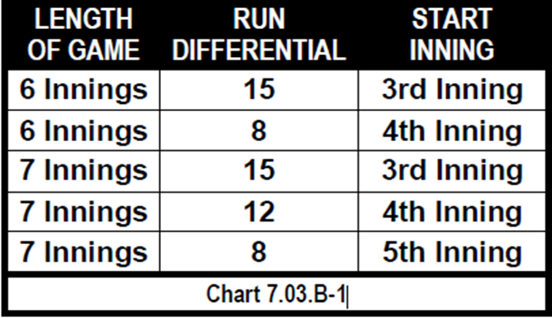

Start of Games
All pool play games home team will be decided by coin flip.
Championship bracket games the higher seed will be home team.
Championship game home team will be decided by coin flip.
Home team will keep the book and Visiting team will run the scoreboard when applicable
Pitching Rules
USSSA PITCHING RULES SUGGESTED BUT NOT TRACKED
PROTEST
NO PROTEST: THE HEAD UMPIRE AND TOURNAMENT DIRECTOR WILL MAKE FINAL DECISION

