Pitch Counts?
There is a lot of discussion about pitch counts these days with many different views on their effectiveness. I personally am not a fan of pitch counts but understand the need for them in baseball today. There’s been many experts in and out of baseball take a look at this and they cannot seem to agree with the magic formula or number of pitches that will protect a young player. The problem is not every kid is the same and not every pitch is the same so the numbers thrown out are pretty much arbitrary.
Let me tell you why I understand the need for them even though I’m not a big fan. With baseball today there is not enough proper preparation for what we put a young pitcher’s arm through. I am not only talking about off season workouts and pre-season pitching programs which is important but kids these days do not play enough catch, I am a firm believer that at young ages kids need to play more catch and less pitching. Another reason is most youth coaches do not understand what recovery actually is, it is not necessarily doing nothing until a player pitches again. Recovery can cover a lot of areas from long toss, band work, rest, stretching and many more things you do to maintain your body and arm. With these missing key elements something needs to be in place to protect the kids arm but is it an arbitrary number that might help some but not all kids? I can tell you with the set-up of baseball today I don’t have the answer.
Now if you couldn’t tell some of the reasons from the above paragraph why I am not a fan I will help elaborate more. Overuse is used as a reason for the increase in UCL surgeries (Tommy John) so everyone’s main focus now is limit overuse in young pitchers! Sounds good right? If that’s the case, why is UCL surgeries still on the rise? Look at a chart from MLB disable list and the history of UCL surgeries since 1974 through 2014. (Disclaimer I Am Not Saying Pitch Counts Cause the Rise of UCL Injuries)

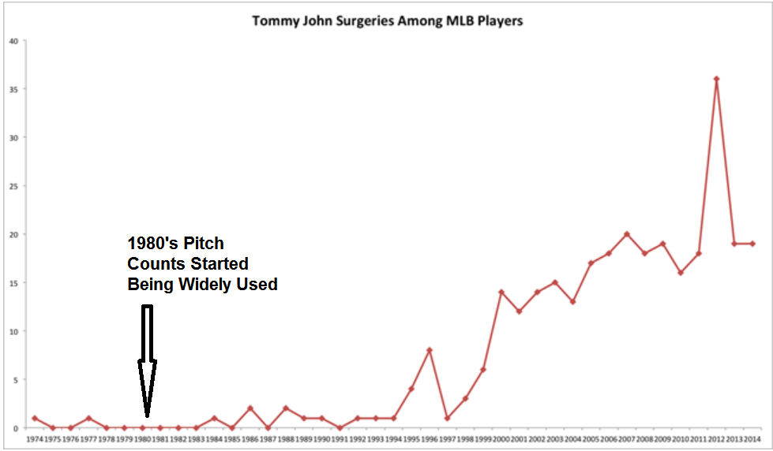
Now again I am not saying that pitch counts are to blame and the evil behind our arm injury epidemic because there’s way too many factors at play. Is it because of the expansion of travel ball and elite teams? Is it Doctors diagnose it more than in the past? I don’t know the answer maybe it would be 3x as high without pitch counts? What I would like you to consider is how do we get a muscle stronger (there is a lot of different muscles at play here) we push that muscle, we work that muscle and when we stop at an arbitrary number is it too much for an arm? Or is it not enough to allow arm muscles to grow and get stronger? We don’t know because every person is different and that pitch count number is different for each player. We do need to strengthen all the muscles involved in throwing and overuse is not a positive but underuse will not allow the arm to get stronger. Strengthening the muscles for throwing is done through a combination of different workouts from long toss, plyo-balls, under & over loading, J-bands, lifting and proper recovery programs.
My conclusion, pitch counts might be necessary and might help protect some kids but they also could be making some kids arms soft and making them more susceptible to arm injuries. If you are a parent trying to help your kid make it to the next level, you need to take your kids arm into your own hands and help to strengthen it by doing your research or relying on someone you trust who has done the research for the best path for you kid. I am a believer (haven’t always been but am now) that a kid doesn’t have to play 100 games a summer or they will get behind or not get the exposure they need. If their arm is not healthy or lacks the velocity required they will get exposed alright but for the wrong reasons! Make sure when they are exposed it is for the right reasons. It is important to have a Physical Therapist or trainer do an assessment to look for deficient movement patterns and a coach to look for mechanical flaws in your throwing that could be a primary driver of arm injuries and pains. One other key we don’t want to forget is pain, pain could be the key to protecting your arm. We don’t necessarily need to view pain as bad but as another source of information to help keep our arm healthy. Pain is telling us something and as coaches, players, and parents we need to listen. In a lot of cases it is not just a sign of overuse but a sign of mechanical issues or lack of recovery among other things. Please keep in mind that if you are relying on games and live pitching as your primary arm program then your baseball career will more than likely be short lived and fall short of your goals as a player. Pitch counts? I don’t know the correct answer but I do feel it is important that we keep asking the question!

